Synyuk Andrey
Position applied for: 3rd Officer  Date of birth: 18.07.1978 (age: 39)  Citizenship: Ukraine  Residence permit in Ukraine: No  Country of residence: Ukraine  City of residence: Zhytomyr  Permanent address: kosmonavtov str. 32b. 17 apt.  Contact Tel. No: +38 (041) 239-68-08 / +38 (067) 454-33-34  E-Mail: andreysynyuk@gmail.com  U.S. visa: No  E.U. visa: No  Ukrainian biometric international passport: Not specified  Date available from: 18.05.2011  English knowledge: Moderate  Minimum salary: 2200 $ per month | 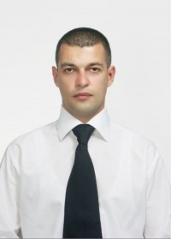

Experience:
Position | From / To | Vessel name | Vessel type | DWT | ME | BHP | Flag | Shipowner | Crewing
3rd Officer | 20.08.2010-21.01.2011 | trader | Bulk Carrier | 5000 |  | - | st.winsent and grena | dual invest | MCA
Able Seaman | 22.12.2009-18.04.2010 | royal iris | Passenger Ship | 9159 |  | - | panama | golden cruises ltd | epsilon maritime services
AB-Carpenter | 15.07.2009-21.12.2009 | the iris | Passenger Ro-Ro Ship | 12825 |  | - | malta | silver cruises ltd | epsilon maritime services
Able Seaman | 13.11.2008-05.02.2009 | the iris | Passenger Ro-Ro Ship | 12825 |  | - | malta | silver cruises ltd | epsilon maritime services
Able Seaman | 16.08.2007-12.11.2008 | royal iris | Passenger Ship | 9159 |  | - | panama | golden cruises ltd | epsilon maritime servises

