Семеняка Геннадий Николаевич
Position applied for: Cook  Date of birth: 21.12.1964 (age: 52)  Citizenship: Ukraine  Residence permit in Ukraine: No  Country of residence: Ukraine  City of residence: Berdyansk  Permanent address: ул.Степанянца, 2 кв. 244  Contact Tel. No: +38 (067) 948-23-67  E-Mail: podumey@bk.ru  U.S. visa: No  E.U. visa: No  Ukrainian biometric international passport: Not specified  Date available from: 01.07.2009  English knowledge: Good  Minimum salary: 1300 $ per month | 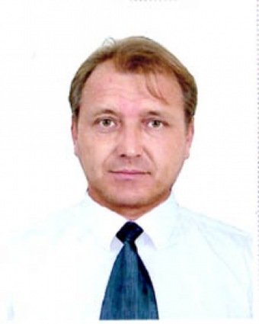

Experience:
Position | From / To | Vessel name | Vessel type | DWT | ME | BHP | Flag | Shipowner | Crewing
Cook | 29.04.2008-13.01.2009 | Paris | Bulk Carrier | 12000 |  | - |  | Hedway Ltd | &mdash;
Cook | 02.05.2007-15.12.2007 | Fatezh | Bulk Carrier | 6000 |  | - |  | CFD Ltd | &mdash;
Cook | 30.03.2006-29.07.2006 | Svyatoy Vasiliy | Bulk Carrier | 24000 |  | - |  | Comitan Shipping Ltd | &mdash;
Cook | 22.11.2005-02.07.2005 | Almansoor-1 | Bulk Carrier | 9000 |  | - |  | Ashapura Shipping Co | &mdash;
Cook | 22.11.2004-01.03.2005 | Marina | Shuttle Tanker | 3000 |  | - |  | Global Consulting | &mdash;

Documents and further information:
International Passport (N°/issued at/date of issue/date of expire): EK 104257 //07 April 2009//07 April 2019
Seamans Id. Card (N°/issued at/date of issue/date of expire): AB 323510//21 December 2006//21 December 2011
Certificate of Competency (N°/issued at/date of issue): 00024//2006/06//22 March 2006
Grade:Ship*s cook
Endorsement (N°/issued at/date of issue/date of expire): 0024/2006/06//22 March 2006

