Shevtsov Pavlo
Position applied for: 2nd Officer  Date of birth: 31.10.1985 (age: 32)  Citizenship: Ukraine  Residence permit in Ukraine: No  Country of residence: Ukraine  City of residence: Sevastopol  Permanent address: B.Mikhailova 3-a/61  Contact Tel. No: +38 (099) 121-58-21  E-Mail: stani.ecvilebrium@mail.ru  U.S. visa: No  E.U. visa: No  Ukrainian biometric international passport: Not specified  Date available from: 20.11.2013  English knowledge: Good  Minimum salary: 3500 $ per month | 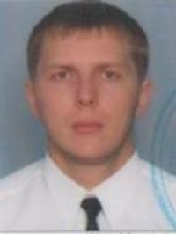

Experience:
Position | From / To | Vessel name | Vessel type | DWT | ME | BHP | Flag | Shipowner | Crewing
2nd Officer | 02.10.2012-09.02.2013 | Almeda Star | Refrigerator | 11056 |  | - | Bahama |  | Starreefers Poland
2nd Officer | 17.02.2012-12.06.2012 | Almeda Star | Refrigerator | 11056 |  | - | Bahama |  | Starreefers Poland
3rd Officer | 14.08.2011-09.01.2012 | Honduras Star | Refrigerator | 10658 |  | - | Liberia |  | Starreefers Poland
3rd Officer | 22.09.2010-22.03.2011 | Canarian Reefer | Refrigerator | 6989 |  | - | Panama | Laskaridis | &mdash;
3rd Officer | 11.12.2009-18.05.2010 | Eurofrost | Refrigerator | 6989 |  | - | Panama | Laskaridis | &mdash;
3rd Officer | 22.09.2008-23.03.2009 | Saronic Breeze | Refrigerator | 6989 |  | - | Panama | Laskaridis | &mdash;

