Aravin Aleksey
Position applied for: Ordinary Seaman  Date of birth: 02.10.1998 (age: 19)  Citizenship: Russia  Residence permit in Ukraine: Yes  Country of residence: Russia  City of residence: Moscow  Permanent address: Moscow, Rechnikov St., 16  Contact Tel. No: +7 (964) 944-89-53  E-Mail: asts61@bk.ru  Skype: 123456 No Skype  U.S. visa: No  E.U. visa: No  Ukrainian biometric international passport: Not specified  Date available from: 05.04.2017  English knowledge: Poor  Minimum salary: 900 $ per month | 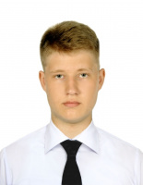

Experience:
Position | From / To | Vessel name | Vessel type | DWT | ME | BHP | Flag | Shipowner | Crewing
Crew Utility | 17.05.2016-30.08.2016 | ILYA REPIN | Passenger Ship | 2100 | 1800 | 1800 | Russia | Moscow tourist fleet | &mdash;

