Kysil Roman Anatoly
Position applied for: Ordinary Seaman  Date of birth: 04.05.1990 (age: 27)  Citizenship: Ukraine  Residence permit in Ukraine: No  Country of residence: Ukraine  City of residence: Odessa  Contact Tel. No: +38 (063) 944-58-64 / +38 (096) 642-25-76  E-Mail: roma_kisil@ukr.net  U.S. visa: No  E.U. visa: No  Ukrainian biometric international passport: Not specified  Date available from: 01.05.1990  English knowledge: Moderate  Minimum salary: 900 $ per month | 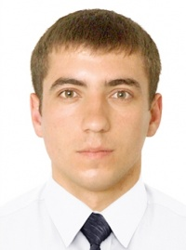

Experience:
Position | From / To | Vessel name | Vessel type | DWT | ME | BHP | Flag | Shipowner | Crewing
Ordinary Seaman | 15.12.2011-18.07.2012 | Callio | Bulk Carrier | 27420 |  | - | Cyprus | Narval Shipping Co.LTD | Leader Marine Management

