Kravchenko Ivan Aleksandrovich
Position applied for: Able Seaman  Date of birth: 07.02.1986 (age: 31)  Citizenship: Ukraine  Residence permit in Ukraine: No  Country of residence: Ukraine  City of residence: Krasnoperekopsk  Contact Tel. No: +38 (099) 789-56-91  E-Mail: vanokrava@gmail.com  U.S. visa: No  E.U. visa: No  Ukrainian biometric international passport: Not specified  Date available from: 03.06.2013  English knowledge: Moderate  Minimum salary: 1500 $ per month | 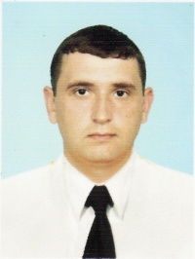

Experience:
Position | From / To | Vessel name | Vessel type | DWT | ME | BHP | Flag | Shipowner | Crewing
Able Seaman | 04.12.2013-20.04.2014 | ROUBINI K | Bulk Carrier | 16600 |  | - | Malta |  | &mdash;
Steward | 22.06.2013-25.11.2013 | Hector | Bulk Carrier | 75200 | MAN B&W | 8833 kW | Liberia |  | &mdash;
Able Seaman | 23.03.2012-10.01.2013 | Alessandra 1 | General Cargo | 14265 | MAK | - | Malta | NAVITRAMP FREIGHT AGENCY LTD | TRANSYUG SHIPPING CO LTD

