Sytnik Vyacheslav
Position applied for: 2nd Officer  Date of birth: 13.05.1985 (age: 32)  Citizenship: Ukraine  Residence permit in Ukraine: Yes  Country of residence: Ukraine  City of residence: Odessa  Contact Tel. No: +38 (048) 766-29-22 / +38 (050) 336-18-17  E-Mail: vyacheslav_sytnik@mail.ru  U.S. visa: No  E.U. visa: No  Ukrainian biometric international passport: Not specified  Date available from: 20.02.2014  English knowledge: Excellent  Minimum salary: 5000 $ per month | 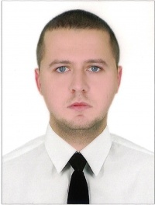

Experience:
Position | From / To | Vessel name | Vessel type | DWT | ME | BHP | Flag | Shipowner | Crewing
Chief Officer | 09.05.2013-29.09.2013 | Funchal | Passenger Ship |  |  | - |  |  | &mdash;
Safety Officer | 20.04.2012-29.10.2012 | Princess Daphne | Passenger Ship |  |  | - |  |  | &mdash;
2nd Officer | 30.04.2011-25.11.2011 | Royal Iris | Passenger Ship |  |  | - |  |  | &mdash;
2nd Officer | 15.04.2010-21.12.2010 | Royal Iris | Passenger Ship |  |  | - |  |  | &mdash;
3rd Officer | 23.02.2009-08.12.2009 | Royal Iris | Passenger Ship |  |  | - |  |  | &mdash;

