Podmazko Vladyslav
Position applied for: Engine Cadet  Date of birth: 08.07.1998 (age: 19)  Citizenship: Ukraine  Residence permit in Ukraine: Yes  Country of residence: Ukraine  City of residence: Odessa  Permanent address: Grecheskaya 9  Contact Tel. No: +38 (063) 596-77-44  E-Mail: podmazko2012@yandex.ua  Skype: kipe-123  U.S. visa: No  E.U. visa: No  Ukrainian biometric international passport: Not specified  Date available from: 25.04.2017  English knowledge: Good  Minimum salary: 400 $ per month | 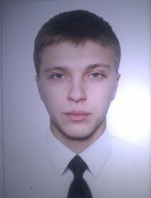

Documents and further information:
I am the cadet of the maritime college A.M Marinesko,Im looking for experience .
At the moment, I do not have any experience, except for workshops at the college.

