Polishchuk Evgeny
Position applied for: 2nd Officer  Date of birth: 14.03.1973 (age: 44)  Citizenship: Russia  Residence permit in Ukraine: Yes  Country of residence: Ukraine  City of residence: Mariupol  Permanent address: Pionera Balabuxi 48-a  Contact Tel. No: +38 (095) 431-67-74  E-Mail: evgenpolishchuk7385@gmail.com  Skype: evgen7385  U.S. visa: No  E.U. visa: No  Ukrainian biometric international passport: Not specified  Date available from: 25.06.2017  English knowledge: Moderate  Minimum salary: 1700 $ per month | 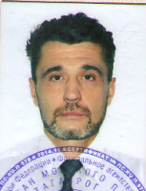

Experience:
Position | From / To | Vessel name | Vessel type | DWT | ME | BHP | Flag | Shipowner | Crewing
2nd Officer | 18.01.2017-28.05.2017 | Tanais | General Cargo | 7078 | Wartsila | 2x1150 | Russia | Donrechflot Ltd | Donrechflot Ltd

Documents and further information:
As a second mate, I had the duties of a cargo officer, and I also have additional education - I graduated from the medical college in 1992y.

