Bykov Yuriy
Position applied for: 2nd Officer  Date of birth: 03.12.2013 (age: 3)  Citizenship: Ukraine  Residence permit in Ukraine: No  Country of residence: Ukraine  City of residence: Odessa  Contact Tel. No: +38 (048) 249-36-77 / +38 (067) 271-06-94  E-Mail: ybykov@rambler.ru  U.S. visa: No  E.U. visa: No  Ukrainian biometric international passport: Not specified  Date available from: 20.01.2013  English knowledge: Good  Minimum salary: 3800 $ per month | 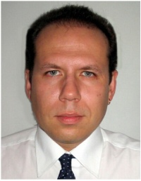

Experience:
Position | From / To | Vessel name | Vessel type | DWT | ME | BHP | Flag | Shipowner | Crewing
2nd Officer | 04.06.2013-19.11.2013 | Iron Queen | Bulk Carrier | 81155 |  | 15215 kWt | Isle Of Man | Breeze Shipping Ltd | Starline

