Grekhov Oleg Leonidovich
Position applied for: Single Engineer  Date of birth: 17.11.1966 (age: 51)  Citizenship: Ukraine  Residence permit in Ukraine: No  Country of residence: Ukraine  City of residence: Odessa  Permanent address: 92.dobrovolskogo,fl. 111  Contact Tel. No: +38 (048) 753-44-77 / +38 (067) 487-76-20  E-Mail: ogrekhov@ukr.net  U.S. visa: No  E.U. visa: No  Ukrainian biometric international passport: Not specified  Date available from: 01.04.2013  English knowledge: Good  Minimum salary: 7000 $ per month | 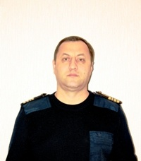

Experience:
Position | From / To | Vessel name | Vessel type | DWT | ME | BHP | Flag | Shipowner | Crewing
Single Engineer | 10.10.2010-11.11.2012 | ocean nova | Passenger Ship | 2186 | MAN&BW | 5000 | bahamas | nova crusing ltd | global marine service,ukraine
Single Engineer | 20.09.1999-23.10.2009 | island adventure | Passenger Ship | 15410 | pielstick | 9000 | bahamas | maddock trading ltd. | amerigo

