Lytovka Dmytro
Position applied for: Electrical Engineer  Date of birth: 24.04.1985 (age: 32)  Citizenship: Ukraine  Residence permit in Ukraine: No  Country of residence: Ukraine  City of residence: Kremenchuk  Contact Tel. No: +38 (063) 944-59-55  E-Mail: Lytovka.D@yandex.ua  U.S. visa: No  E.U. visa: No  Ukrainian biometric international passport: Not specified  Date available from: 18.09.2018  English knowledge: Excellent  Minimum salary: 5000 $ per month | 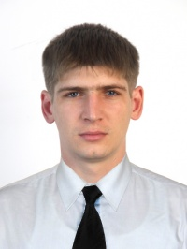

Experience:
Position | From / To | Vessel name | Vessel type | DWT | ME | BHP | Flag | Shipowner | Crewing
 | 14.11.2013-22.04.2014 | Sementina | Bulk Carrier | 7300 | Daihatsu | 2500 | malta |  | V-Ships
Electrician | 23.03.2013-27.07.2013 | BARRA | Bulk Carrier | 45000 | Sulzer | 9500 | PANAMA | STAM SHIPPING | Adriatica
Electrician | 24.10.2012-10.01.2013 | Desert Wind | Bulk Carrier |  | Sulzer | - | Greece |  | IMMA
Electrician | 05.01.2012-08.08.2012 | Atlantic Trader | Lo-Ro |  | MAN | - | Malta | ATLANTIC RO-RO CARRIERS | Atlantic ship management (Lumar)
Electrician | 21.02.2011-13.04.2011 | Atlantic Dream | Lo-Ro |  | MAN | - | MALTA | ATLANTIC RO-RO CARRIERS | LUMAR

Documents and further information:
Good English. Exp. with electrical and el.-hydraulic cranes. Worked in mixed crews. ready to start in July.

