Sliepych Yurii
Position applied for: Cook  Date of birth: 28.08.1988 (age: 29)  Citizenship: Ukraine  Residence permit in Ukraine: Yes  Country of residence: Ukraine  City of residence: Kherson  Permanent address: Moldyozhnaya str.44 Olgovko Kherson reg.  Contact Tel. No: +38 (095) 586-52-31  E-Mail: sleeepp@mail.ru  Skype: aspire5750zg1  U.S. visa: No  E.U. visa: No  Ukrainian biometric international passport: Not specified  Date available from: 29.03.2017  English knowledge: Poor  Minimum salary: 1000 $ per month | 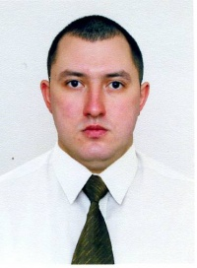

Experience:
Position | From / To | Vessel name | Vessel type | DWT | ME | BHP | Flag | Shipowner | Crewing
Cook | 15.06.2016-30.12.2016 | m/v ENVAR | General Cargo |  |  | - | Panama | Safir gemi tasimacilik | MS CREWING
Cook | 22.03.2015-20.09.2015 | m/v EVALUNA | General Cargo |  |  | - | Valletta | Premius maritime co.ltd | Golfstrim
Cook | 13.07.2014-24.01.2015 | M/V SANAD | Multi-Purpose Vessel | 4015 |  | - | BAHRAIN | TYLOS SHIPPING & MARINE SERVICES | ALMAGEST
Cook | 29.10.2014-30.03.2014 | "ULFAT" | Ro-Ro | 5309 |  | - | Phnom Penh | Capital Enterprises Corporation | Allians Navigation
Cook | 14.06.2013-20.08.2013 | m/v vega | General Cargo | 2516 |  | - | Giurgiulessti | FIX TRADING END SHIPPING LTD.CORP | BETELGEIZE

