Быстрянцев Сергей Юриевич
Position applied for: Cook  Date of birth: 18.02.1976 (age: 41)  Residence permit in Ukraine: No  Country of residence: Ukraine  City of residence: Bakhchisaray  Permanent address: Мало-Садовое, пер.Лесной, 3  Contact Tel. No: +38 (050) 406-18-00 / +38 (065) 546-39-76  E-Mail: Shadow.2007@list.ru  U.S. visa: No  E.U. visa: No  Ukrainian biometric international passport: Not specified  Date available from: 12.09.2010  English knowledge: Moderate  Minimum salary: 800 $ per month | 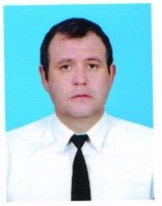

Experience:
Position | From / To | Vessel name | Vessel type | DWT | ME | BHP | Flag | Shipowner | Crewing
Cook | 18.06.2009-23.12.2009 | Aras-1 | Dry Cargo | 3943т | Г-70 | - | молдавия | Transoptimal shipping | Гольфстрим

