Maslov Alexander
Position applied for: Master  Date of birth: 23.12.1973 (age: 43)  Citizenship: Russia  Residence permit in Ukraine: No  Country of residence: Russia  City of residence: Rostov-na-Donu  Contact Tel. No: +7 (905) 662-36-37 / +7 (988) 566-00-09  E-Mail: master231273@mail.ru  U.S. visa: No  E.U. visa: No  Ukrainian biometric international passport: Not specified  Date available from: 21.03.2014  English knowledge: Good  Minimum salary: 4000 $ per month | 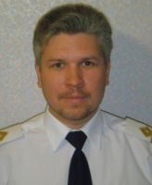

Experience:
Position | From / To | Vessel name | Vessel type | DWT | ME | BHP | Flag | Shipowner | Crewing
Master | 08.06.2013-16.11.2013 | Dorado Plus | General Cargo | 6933 | WARTSILA 6 L20 | - | MALTA | Ultramarine Ltd. | World and Seaman
Master | 27.11.2012-06.05.2013 | Omskiy-6 | General Cargo | 3095 | 6 NVD 48A-2U | - | RUSSIA | Marship Ltd. | &mdash;

