Pauk Viktor
Position applied for: Wiper  Date of birth: 17.03.1990 (age: 27)  Citizenship: Ukraine  Residence permit in Ukraine: No  Country of residence: Ukraine  City of residence: Kyiv  Contact Tel. No: +38 (068) 760-75-29  E-Mail: Pauchok_Viktor@ukr.net  U.S. visa: No  E.U. visa: No  Ukrainian biometric international passport: Not specified  Date available from: 01.09.2012  English knowledge: Poor  Minimum salary: 600 $ per month | 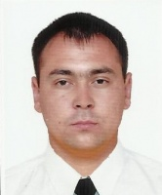

Experience:
Position | From / To | Vessel name | Vessel type | DWT | ME | BHP | Flag | Shipowner | Crewing
Motorman-Oiler | 01.04.2009-29.09.2009 | Dniper Star | Passenger Ship |  |  | - |  |  | &mdash;
Motorman-Oiler | 01.09.2008-09.11.2008 | Dniper Star | Passenger Ship |  |  | - |  |  | &mdash;

