Ponomarov Volodymyr Volodymyrovich
Position applied for: 2nd Engineer  Date of birth: 05.05.1975 (age: 42)  Citizenship: Ukraine  Residence permit in Ukraine: No  Country of residence: Ukraine  City of residence: Kherson  Permanent address: Budyonnogo 12  Contact Tel. No: +38 (055) 233-72-98 / +38 (067) 866-07-53  E-Mail: supervovka@ua.fm  U.S. visa: No  E.U. visa: No  Ukrainian biometric international passport: Not specified  Date available from: 10.09.2013  English knowledge: Excellent  Minimum salary: 9000 $ per month | 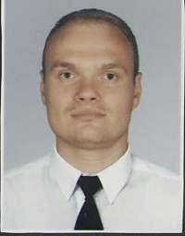

Experience:
Position | From / To | Vessel name | Vessel type | DWT | ME | BHP | Flag | Shipowner | Crewing
2nd Engineer | 23.05.2013-26.07.2013 | Union Sapphire | Anchor Handling Tug Supply | 500 | ABC | 4960 | Belgium | Boskalis | Eugenia
2nd Engineer | 15.12.2012-01.03.2013 | Union Warrior | Anchor Handling Tug Supply | 945 | ABC | 7100 | Belgium | SMIT Transport | Eugenia

