Ananyev Oleksandr
Position applied for: Chief Officer  Date of birth: 15.09.1986 (age: 31)  Citizenship: Ukraine  Residence permit in Ukraine: Yes  Country of residence: Ukraine  City of residence: Kherson  Contact Tel. No: +38 (050) 513-63-06 / +38 (055) 246-96-15  E-Mail: ananyev-cap@mail.ru  U.S. visa: No  E.U. visa: No  Ukrainian biometric international passport: Not specified  Date available from: 20.10.2014  English knowledge: Good  Minimum salary: 3000 $ per month | 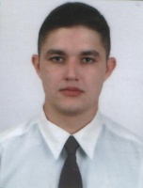

Experience:
Position | From / To | Vessel name | Vessel type | DWT | ME | BHP | Flag | Shipowner | Crewing
Chief Officer | 02.02.2014-07.07.2014 | Volgo-Balt 242 | General Cargo | 4200 | Shkoda x 2 | - | Moldova | Sea Logistic Intrnational LTD | Eurobalk (Odessa)

