Ivanov Oleksandr
Position applied for: Cook  Date of birth: 10.10.1970 (age: 47)  Citizenship: Ukraine  Residence permit in Ukraine: No  Country of residence: Ukraine  City of residence: Sevastopol  Permanent address: Tereschenko str.1 app.6  Contact Tel. No: +38 (050) 143-20-40 / +38 (069) 254-69-14  E-Mail: husenok2009@mail.ru  U.S. visa: No  E.U. visa: No  Ukrainian biometric international passport: Not specified  Date available from: 15.03.2014  English knowledge: Moderate  Minimum salary: 2100 $ per month | 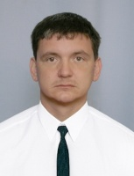

Experience:
Position | From / To | Vessel name | Vessel type | DWT | ME | BHP | Flag | Shipowner | Crewing
Cook | 01.02.2013-02.02.2014 | Strickling Tide | Anchor Handling Tug Supply |  |  | - | Vanuatu | Tidewater | Seacover

