Godovanets Maksym
Position applied for: Cook  Date of birth: 15.07.1991 (age: 26)  Citizenship: Ukraine  Residence permit in Ukraine: No  Country of residence: Ukraine  City of residence: Chornomorsk  Permanent address: Geroiv Stalingrada 10/158  Contact Tel. No: +38 (063) 493-57-76  E-Mail: mivina_15@mail.ru  U.S. visa: No  E.U. visa: No  Ukrainian biometric international passport: Not specified  Date available from: 31.12.2013  English knowledge: Moderate  Minimum salary: 1300 $ per month | 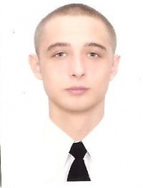

Experience:
Position | From / To | Vessel name | Vessel type | DWT | ME | BHP | Flag | Shipowner | Crewing
Steward | 04.06.2012-04.01.2013 | CHESTNUT | Bulk Carrier | 30809 |  | - | Cyprus |  | Daphne Shiping
Cook | 24.07.2011-31.12.2011 | STEPANIDA | Bulk Carrier | 5756 |  | - | cambodia |  | Azimut

