Tyshchenko Sergiy
Position applied for: Ordinary Seaman  Date of birth: 22.03.1992 (age: 25)  Citizenship: Ukraine  Residence permit in Ukraine: Yes  Country of residence: Ukraine  City of residence: Mariupol  Permanent address: 16 Novorossiyska st. ft.132  Contact Tel. No: +38 (098) 107-47-41  E-Mail: sergeitishenko@gmail.com  Skype: gscream3  U.S. visa: Yes. Expiration date 14.02.2026  E.U. visa: No  Ukrainian biometric international passport: Not specified  Date available from: 25.02.2017  English knowledge: Moderate  Minimum salary: 400 $ per month | 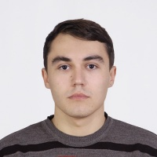

Experience:
Position | From / To | Vessel name | Vessel type | DWT | ME | BHP | Flag | Shipowner | Crewing
Mess Boy | 08.03.2016-20.10.2016 | CMA CGM Rabelais | Container Ship |  |  | - |  |  | &mdash;

