Usaty Yuriy Alekseyevich
Position applied for: Cook  Date of birth: 10.07.2017 (age: 0)  Citizenship: Ukraine  Residence permit in Ukraine: Yes  Country of residence: Ukraine  City of residence: Odessa  Permanent address: Lavochna 21  Contact Tel. No: +38 (067) 709-77-13  E-Mail: usaty1965@gmail.com  Skype: Yura469  U.S. visa: No  E.U. visa: No  Ukrainian biometric international passport: Not specified  Date available from: 31.07.2017  English knowledge: Moderate  Minimum salary: 1700 $ per month | 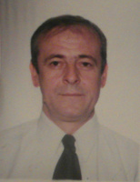

Experience:
Position | From / To | Vessel name | Vessel type | DWT | ME | BHP | Flag | Shipowner | Crewing
Cook | 14.04.2016-03.12.2016 | Mandarin | Bulk Carrier | 18 311 |  | - | Cyprys | Freesky Shipping Limited | Duphny Shipping

