Shelmuk Dmytro
Position applied for: 2nd Officer  Date of birth: 14.06.1986 (age: 31)  Citizenship: Ukraine  Residence permit in Ukraine: No  Country of residence: Ukraine  City of residence: Odessa  Contact Tel. No: +38 (048) 235-50-52 / +38 (067) 108-15-47  E-Mail: sheldi_86@mail.ru  Skype: sheldi  U.S. visa: No  E.U. visa: No  Ukrainian biometric international passport: Not specified  Date available from: 10.12.2016  English knowledge: Good  Minimum salary: 3500 $ per month | 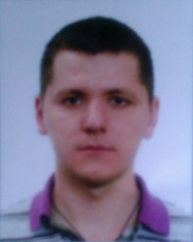

Experience:
Position | From / To | Vessel name | Vessel type | DWT | ME | BHP | Flag | Shipowner | Crewing
2nd Officer | 25.05.2012-23.02.2013 | MSC Adriana | Container Ship | 25219 |  | - | malta | Compania Naviera Adriana S.A. | MSC
Able Seaman | 31.12.2010-31.07.2011 | ZIM Luanda | Container Ship | 40030 |  | - | malta | Black Sea Marine Inc. | Danaos
Ordinary Seaman | 29.11.2008-14.08.2009 | YM Singapore | Container Ship | 41855 |  | - | malta | Welington Marine Inc. | Danaos
Deck Cadet | 29.02.2008-16.07.2008 | YM Milano | Container Ship | 41786 |  | - | Greece | Saratoga Trading S.A. | Danaos

