Georgiyev
Position applied for: 2nd Officer  Date of birth: 04.06.1983 (age: 34)  Citizenship: Ukraine  Residence permit in Ukraine: No  Country of residence: Ukraine  City of residence: Izmail  Permanent address: Suvorova ave., 25  Contact Tel. No: +38 (048) 412-19-42 / +38 (097) 452-11-39  E-Mail: georgiyevroman@mail.ru  U.S. visa: No  E.U. visa: No  Ukrainian biometric international passport: Not specified  Date available from: 01.11.2013  English knowledge: Good  Minimum salary: 3500 $ per month | 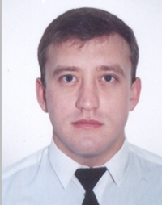

Experience:
Position | From / To | Vessel name | Vessel type | DWT | ME | BHP | Flag | Shipowner | Crewing
2nd Officer | 13.05.2012-07.01.2013 | St.Kiril | Bulk Carrier | 40000 |  | - | Liberia | Unimor | Seagull
2nd Officer | 16.12.2011-10.03.2012 | St.Mark | Bulk Carrier | 40000 |  | - | Liberia | Unimor | Seagull
2nd Officer | 01.10.2010-22.06.2011 | St.Marfa | Bulk Carrier | 40000 |  | - | Liberia | Unimor | Seagull
3rd Officer | 04.09.2009-19.03.2010 | St.Marfa | Bulk Carrier | 40000 |  | - | Liberia | Unimor | Seagull
3rd Officer | 14.03.2009-12.06.2009 | Panagia | Bulk Carrier | 40000 |  | - | Liberia | Unimor | Seagull
3rd Officer | 27.05.2008-17.09.2008 | Mekhanik Yuzvovich | Dry Cargo | 6000 |  | - | Ukraine | CFD | CFD

