Shishko Sergey
Position applied for: AB-Cook  Date of birth: 17.10.1981 (age: 36)  Citizenship: Ukraine  Residence permit in Ukraine: No  Country of residence: Ukraine  City of residence: Kherson  Permanent address: Tsiolkovskogo 39  Contact Tel. No: +38 (099) 373-27-84  E-Mail: sergeyshishko77@gmail.com  U.S. visa: No  E.U. visa: No  Ukrainian biometric international passport: Not specified  Date available from: 01.02.2013  English knowledge: Poor  Minimum salary: 1700 $ per month | 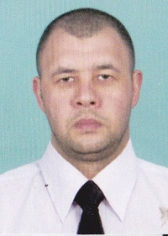

Experience:
Position | From / To | Vessel name | Vessel type | DWT | ME | BHP | Flag | Shipowner | Crewing
AB-Cook | 30.11.2011-25.03.2012 | Bente | Bulk Carrier | 5000 |  | - | malta |  | &mdash;

