Tishchenko Oleksiy
Position applied for: Electrician  Additional position applied for: Electrical Engineer  Date of birth: 03.06.1982 (age: 35)  Citizenship: Ukraine  Residence permit in Ukraine: Yes  Country of residence: Ukraine  City of residence: Odessa  Contact Tel. No: +38 (093) 709-74-16  E-Mail: tischenko12@yandex.ru  Skype: tischenko1212  U.S. visa: No  E.U. visa: No  Ukrainian biometric international passport: Not specified  Date available from: 30.06.2017  English knowledge: Good  Minimum salary: per month | 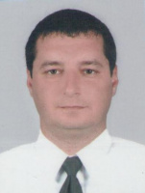

Experience:
Position | From / To | Vessel name | Vessel type | DWT | ME | BHP | Flag | Shipowner | Crewing
Electrician | 00.00.0000-00.00.0000 |  |  |  |  | - |  |  | &mdash;

