Veremenko Viktor Nykolaevich
Position applied for: 3rd Officer  Date of birth: 03.10.1982 (age: 35)  Citizenship: Ukraine  Residence permit in Ukraine: No  Country of residence: Ukraine  City of residence: Odessa  Permanent address: app. 82, 28, Geroev Stalingrada str., Odessa, Ukraine  Contact Tel. No: +38 (048) 252-25-93 / +38 (063) 607-76-37  E-Mail: vermenko.viktor@rambler.ru  U.S. visa: No  E.U. visa: No  Ukrainian biometric international passport: Not specified  Date available from: 07.02.2017  English knowledge: Good  Minimum salary: 3200 $ per month | 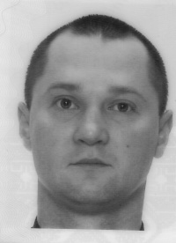

Experience:
Position | From / To | Vessel name | Vessel type | DWT | ME | BHP | Flag | Shipowner | Crewing
3rd Officer | 13.08.2013-12.11.2013 | PANGANI | Heavy Lift Vessel | 8132 | MAK | 6300 kW | GIBRALTAR | K/S Thunder Bird | Marlow Navigation
Able Seaman | 28.04.2013-12.08.2013 | PANGANI | Heavy Lift Vessel | 8132 | MAK | 6300 kW | GIBRALTAR | K/S Thunder Bird | Marlow Navigation
Able Seaman | 17.03.2012-22.09.2012 | PALMERTON | Heavy Lift Vessel | 11473 | MAN | 7200 kW | ATG | Harren and Partner | Marlow Navigation
Able Seaman | 13.03.2011-15.10.2011 | Combi Dock 4 | Heavy Lift Vessel | 17341 | MAN x 2 | 8960 kW | ATG | Harren and Partner | Marlow Navigation

