Kondratsov Anton
Position applied for: Cook  Date of birth: 12.05.1992 (age: 25)  Citizenship: Ukraine  Residence permit in Ukraine: Yes  Country of residence: Ukraine  City of residence: Kherson  Contact Tel. No: +38 (066) 053-23-00  E-Mail: kondratsov@gmail.com  Skype: frequency.  U.S. visa: No  E.U. visa: No  Ukrainian biometric international passport: Not specified  Date available from: 21.03.2017  English knowledge: Poor  Minimum salary: 900 $ per month | 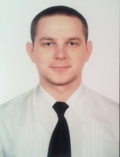

Experience:
Position | From / To | Vessel name | Vessel type | DWT | ME | BHP | Flag | Shipowner | Crewing
Mess Boy | 15.09.2016-15.09.2016 | Emmakris 3 | Bulk Carrier | 73000 |  | - |  |  | &mdash;

