Lavrenov Pavel Nikolaevich
Position applied for: 2nd Officer  Date of birth: 01.01.1987 (age: 30)  Citizenship: Russia  Residence permit in Ukraine: No  Country of residence: Russia  City of residence: Kaliningrad  Permanent address: lane Narva 2/6  Contact Tel. No: +7 (952) 790-39-77  E-Mail: pl.lavrenov@mail.ru  U.S. visa: No  E.U. visa: No  Ukrainian biometric international passport: Not specified  Date available from: 31.01.2014  English knowledge: Moderate  Minimum salary: 2500 $ per month | 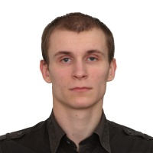

Experience:
Position | From / To | Vessel name | Vessel type | DWT | ME | BHP | Flag | Shipowner | Crewing
2nd Officer | 15.12.2012-14.03.2013 | Sormovskiy 3058 | Dry Cargo | 3853 | 2X870 | - | Russia | NWSC | &mdash;
Deck Cadet | 04.04.2012-29.08.2012 | Oslo Bulk 2 | Bulk Carrier | 7000 | 2900 | - | Singapure | HAV Ship Menegment | &mdash;
Able Seaman | 15.06.2010-01.09.2010 | Kangalassy | Dry Cargo | 3100 |  | - |  |  | -

Documents and further information:
I do not smoke, do not drink, disciplined.

