Zaytsev Andrey
Position applied for: Able Seaman  Date of birth: 18.11.1968 (age: 49)  Citizenship: Ukraine  Residence permit in Ukraine: Yes  Country of residence: Ukraine  City of residence: Kherson  Permanent address: 154 LENIN STREET  Contact Tel. No: +38 (066) 323-12-18 / +38 (096) 767-43-60  E-Mail: zaytsev55@ukr.net  Skype: andruhin551  U.S. visa: Yes. Expiration date 22.03.2026  E.U. visa: Yes. Expiration date 31.12.2022  Ukrainian biometric international passport: Not specified  Date available from: 30.11.2017  English knowledge: Moderate  Minimum salary: 1600 $ per month | 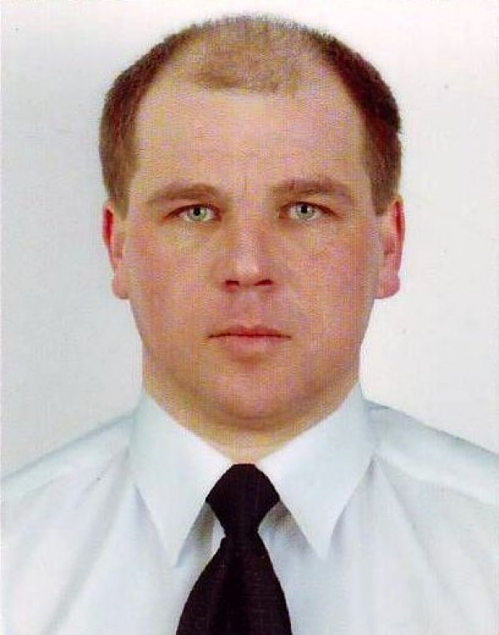

Experience:
Position | From / To | Vessel name | Vessel type | DWT | ME | BHP | Flag | Shipowner | Crewing
Able Seaman | 14.01.2017-09.08.2017 | MSC Caterina | Container Ship | 109581 | B&W | 47430 kWt | Panama | Super Precise Limited | MSC
Able Seaman | 14.03.2016-29.09.2016 | MSC Caterina | Container Ship | 109581 | B&W | 47430 kWt | Panama | Super Precise Limited | MSC
Able Seaman | 16.04.2015-14.11.2015 | MSC Elodie | Container Ship | 109581 | B&W | 47430 kWt | Panama | MaxLuck Global Ltd. | MSC
Able Seaman | 16.05.2014-01.12.2014 | MSC MANU | Container Ship | 52191 |  | 39415 | PANAMA | SEASPAN CORPORATION | MSC
Able Seaman | 13.06.2013-11.02.2014 | MSC NICOLE | Container Ship | 31430 | SULZER | 22094 | PANAMA | GULMARE HOLDINES S.A. | MSC
Able Seaman | 31.05.2012-11.12.2012 | Everest | Multi-Purpose Vessel | 17493 | DMR SULZER 5RTA58 | 7950 | Belize | Deena Shipping Incorporation | Unimars
Able Seaman | 14.04.2011-12.10.2011 | Elbrus | Multi-Purpose Vessel | 17493 | Sulzer | 7950 | Belize | Dalwood Marine Co. | Unimars
Able Seaman | 27.07.2010-06.01.2011 | Safmarine Kwanza | Multi-Purpose Vessel | 17493 | Sulzer | 7950 | Belize | Glenbrook Maritime Co. | Unimars
Able Seaman | 20.05.2010-28.06.2010 | Elbrus | Multi-Purpose Vessel | 17493 | Sulzer | 7950 | Belize | Dalwood Marine Co. | Unimars
Able Seaman | 02.07.2009-09.02.2010 | Elbrus | Multi-Purpose Vessel | 17493 | DMR SULZER 5RTA58 | 7950 | Belize | Dalwood Marine Co. | Unimars
Able Seaman | 26.10.2008-30.04.2009 | Safmarine Cavalla | Multi-Purpose Vessel | 17493 | DMR SULZER 5RTA58 | 7950 | Belize | Deena Shipping Incorporation | Unimars
Steward | 07.02.2008-27.07.2008 | African Lark | Multi-Purpose Vessel | 17493 | DMR SULZER 5RTA58 | 7950 | Belize | Milmead Shipping S.A. | Unimars
Able Seaman | 14.01.2007-15.08.2007 | Rusalka | Dry Cargo | 4300 | DR-2*1000 | 1490 | Cambodia | Rusalka Shipping S.A.(Turky) | Murena

Documents and further information:
Have experience with General cargo & Multiporpose,Container vessel\s(all tipe cargo),40t cranes.All documents & certificated are valid,US visa

