Zaika Viktor
Position applied for: Master  Date of birth: 09.11.1972 (age: 45)  Citizenship: Ukraine  Residence permit in Ukraine: No  Country of residence: Ukraine  City of residence: Kyiv  Contact Tel. No: +38 (044) 530-58-28 / +38 (095) 300-49-20  E-Mail: vzaika72@mail.ru  U.S. visa: No  E.U. visa: No  Ukrainian biometric international passport: Not specified  Date available from: 20.01.2014  English knowledge: Good  Minimum salary: 9000 $ per month | 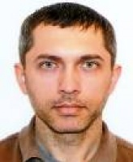

Experience:
Position | From / To | Vessel name | Vessel type | DWT | ME | BHP | Flag | Shipowner | Crewing
Master | 15.09.2013-17.12.2013 | STELAMARIS EHCO | DSV - Diving Support Vessel | 1360 | UCM Resita | 4900 | Nigeria | Ehco Ventures Ltd | CRS (Odessa)

Documents and further information:
.

