Sopin Volodymyr Alexandrovich
Position applied for: Able Seaman  Date of birth: 02.11.2013 (age: 4)  Citizenship: Ukraine  Residence permit in Ukraine: No  Country of residence: Ukraine  City of residence: Kerch  Permanent address: str.Dubinina 9/19 aprt.30  Contact Tel. No: +38 (065) 612-36-39 / +38 (066) 063-10-40  E-Mail: vova.sopin@mail.ru  U.S. visa: No  E.U. visa: No  Ukrainian biometric international passport: Not specified  Date available from: 07.12.2013  English knowledge: Poor  Minimum salary: 800 $ per month | 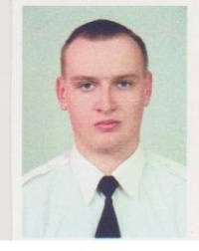

Experience:
Position | From / To | Vessel name | Vessel type | DWT | ME | BHP | Flag | Shipowner | Crewing
Ordinary Seaman | 26.07.2010-04.08.2011 | Crymskaya-7 | Drilling Ship | 1068 | SKL | 2x574 | Ukraine |  | &mdash;
Deck Cadet | 01.02.2008-14.08.2008 | VM-5 | Tug Boat | 116 | SKL | 450 | Ukraine | Special Marine Detachment of MEM MEASURE | &mdash;
Deck Cadet | 24.04.2007-30.10.2007 | VM-5 | Tug Boat | 116 | SKL | 450 | Ukraine | Special Marine Detachment of MEM MEASURE | &mdash;

