Павлов Олег Сергеевич
Position applied for: Chief Officer  Date of birth: 03.08.1982 (age: 35)  Citizenship: Ukraine  Residence permit in Ukraine: No  Country of residence: Ukraine  City of residence: Sevastopol  Contact Tel. No: +38 (095) 410-70-43  E-Mail: pavlov_sev@mail.ru  U.S. visa: No  E.U. visa: No  Ukrainian biometric international passport: Not specified  Date available from: 14.07.2009  English knowledge: Good  Minimum salary: 3300 $ per month | 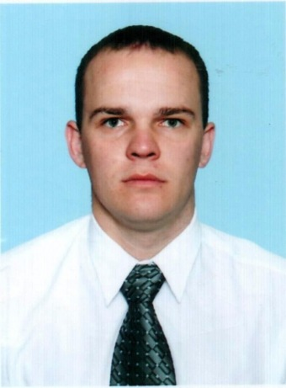

Documents and further information:
все необходимые документы в наличии

