Rudyy Mykhaylo Leonidovich
Position applied for: Mess Boy  Date of birth: 21.11.1980 (age: 36)  Citizenship: Ukraine  Residence permit in Ukraine: No  Country of residence: Ukraine  City of residence: Odessa  Permanent address: ul.Studentskaja,18  Contact Tel. No: +38 (095) 134-13-00  E-Mail: michaelnew@yandex.ru  U.S. visa: No  E.U. visa: No  Ukrainian biometric international passport: Not specified  Date available from: 18.09.2014  English knowledge: Excellent  Minimum salary: 800 $ per month | 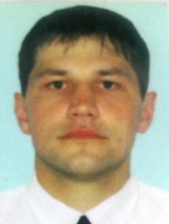

Experience:
Position | From / To | Vessel name | Vessel type | DWT | ME | BHP | Flag | Shipowner | Crewing
Steward | 17.12.2011-21.06.2012 | Disney Magic | Cruise Ship |  |  | - | Bahamas | Disney cruise line | Vships
Steward | 21.04.2011-01.10.2011 | Disney Magic | Cruise Ship |  |  | - | Bahamas | Disney cruise line | Vships
Facilities Cleaner | 12.12.2009-28.06.2010 | Delphin Voyager | Cruise Ship |  |  | - | Bahamas | Delphin shipping LTD | MTC ODESSA
Facilities Cleaner | 30.08.2008-16.07.2009 | Delphin Voyager | Cruise Ship |  |  | - | Bahamas | Delphin shipping LTD | MTC ODESSA

Documents and further information:
visa C1/D

