Uzhelovskyi Ivan
Position applied for: Motorman 1st class  Date of birth: 09.03.1981 (age: 36)  Citizenship: Ukraine  Residence permit in Ukraine: Yes  Country of residence: Ukraine  City of residence: Kherson  Contact Tel. No: +38 (050) 606-30-29  E-Mail: ivan.uzhelovskyi@gmail.com  Skype: uzhelovsky  U.S. visa: No  E.U. visa: No  Ukrainian biometric international passport: Not specified  Date available from: 01.05.2017  English knowledge: Good  Minimum salary: per month | 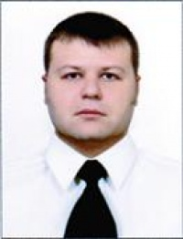

Experience:
Position | From / To | Vessel name | Vessel type | DWT | ME | BHP | Flag | Shipowner | Crewing
Motorman 2nd class | 31.01.2012-20.02.2012 | Safora | Dry Cargo | 1650 | SKL | 2x440 KWt | Russia |  | ACMC
Motorman 2nd class | 05.12.2011-27.01.2012 | Safora | Dry Cargo | 1650 | SKL | 2x440 KWt | Russia |  | ACMC

