Kushnir Lyubomir
Position applied for: 3rd Officer  Date of birth: 18.08.1991 (age: 26)  Citizenship: Ukraine  Residence permit in Ukraine: No  Country of residence: Ukraine  City of residence: Odessa  Permanent address: Odessa  Contact Tel. No: +38 (048) 493-97-82 / +38 (098) 425-67-81  E-Mail: kus-lyubomir@ukr.net  U.S. visa: No  E.U. visa: No  Ukrainian biometric international passport: Not specified  Date available from: 18.03.2013  English knowledge: Good  Minimum salary: 1000 $ per month | 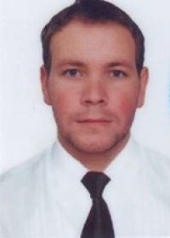

Experience:
Position | From / To | Vessel name | Vessel type | DWT | ME | BHP | Flag | Shipowner | Crewing
Ordinary Seaman | 02.08.2013-12.10.2013 | Baltic sun 2 | Oil Chemical Tanker | 37000 |  | - | Malta | Interirient | univis
Ordinary Seaman | 05.09.2011-26.04.2012 | Boris-Derevynko | Fishing Vessel |  |  | - |  |  | &mdash;
Deck Cadet | 19.01.2010-26.06.2010 | Koralas | Fishing Vessel |  |  | - |  | Litva | Baltanta

