Kostanda Artem
Position applied for: Electrician  Date of birth: 20.01.1981 (age: 36)  Citizenship: Ukraine  Residence permit in Ukraine: Yes  Country of residence: Ukraine  City of residence: Mariupol  Contact Tel. No: +38 (097) 567-56-46  E-Mail: artemkostanda@gmail.com  Skype: artem kostanda  U.S. visa: No  E.U. visa: No  Ukrainian biometric international passport: Not specified  Date available from: 06.09.2017  English knowledge: Good  Minimum salary: 1000 $ per month | 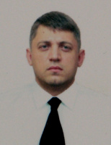

Experience:
Position | From / To | Vessel name | Vessel type | DWT | ME | BHP | Flag | Shipowner | Crewing
Electrician | 01.11.2016-15.05.2017 | DAISY | Dry Cargo | 3000 | CKL | - | Malta | Eagle Sipping LTD | Konkord Crew Company
Electrician | 02.02.2016-28.06.2016 | ABBA | General Cargo | 22000 | B&W | - | Iran | Kalan Kish Shipping Co | Odessa Marin Serves

Documents and further information:
.

