Косых Сергей Александрович
Position applied for: 3rd Officer  Date of birth: 21.10.1986 (age: 31)  Citizenship: Ukraine  Residence permit in Ukraine: No  Country of residence: Ukraine  City of residence: Mariupol  Permanent address: Ул.Полетаева, 22  Contact Tel. No: +38 (098) 574-87-41  E-Mail: sergiykosykh@ukr.net  U.S. visa: No  E.U. visa: No  Ukrainian biometric international passport: Not specified  Date available from: 01.08.2009  English knowledge: Good  Minimum salary: 2400 $ per month | 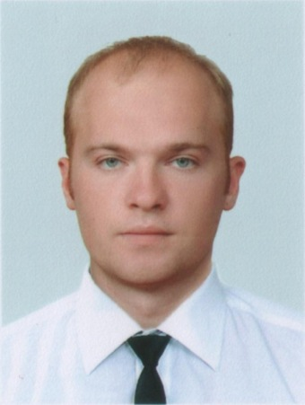

Experience:
Position | From / To | Vessel name | Vessel type | DWT | ME | BHP | Flag | Shipowner | Crewing
Deck Cadet | 13.11.2008-13.04.2009 | Stamatis | Bulk Carrier | 203266 |  | - | Bahamas | Samos Steamship Co. | Барк
Ordinary Seaman | 18.08.2007-24.11.2007 | Baltic Wave | Chemical Tanker | 37000 |  | - | Malta | Interorient | Аврек
Able Seaman | 06.06.2006-17.08.2006 | Lizori | General Cargo | 3000 |  | - | Georgia | Trans-Managment LTD | Аврек

