Kulcha Sergey Ivanovich
Position applied for: Deck Cadet  Date of birth: 05.03.1985 (age: 32)  Citizenship: Ukraine  Residence permit in Ukraine: No  Country of residence: Ukraine  City of residence: &mdash;  Permanent address: 97, kirova str., Izmail  Contact Tel. No: +38 (098) 761-02-29  E-Mail: serj55@list.ru  U.S. visa: No  E.U. visa: No  Ukrainian biometric international passport: Not specified  Date available from: 05.04.2013  English knowledge: Good  Minimum salary: 500 $ per month | 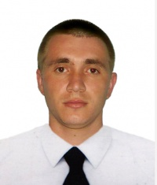

Experience:
Position | From / To | Vessel name | Vessel type | DWT | ME | BHP | Flag | Shipowner | Crewing
Mess Boy | 14.01.2007-24.04.2007 | Sider Lark | Bulk Carrier | 22000 |  | - | Italy | Sider Navi SPA | Libra LTD
Mess Boy | 15.03.2006-20.09.2006 | Sider Faioch | Bulk Carrier | 17300 |  | - | Italy | Sider Navi SPA | Libra LTD

