Zavialov Yevhen
Position applied for: Ordinary Seaman  Additional position applied for: Deck Cadet  Date of birth: 24.08.1996 (age: 21)  Citizenship: Ukraine  Residence permit in Ukraine: Yes  Country of residence: Ukraine  City of residence: Izmail  Permanent address: Gogol Lane 6  Contact Tel. No: +38 (093) 707-97-85  E-Mail: zyablikzav@gmail.com  Skype: thezyablik  U.S. visa: No  E.U. visa: No  Ukrainian biometric international passport: Not specified  Date available from: 01.08.2017  English knowledge: Moderate  Minimum salary: 750 $ per month | 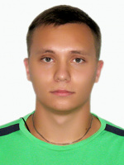

Experience:
Position | From / To | Vessel name | Vessel type | DWT | ME | BHP | Flag | Shipowner | Crewing
Deck Cadet | 02.07.2017-31.08.2015 | Don | Bunkering Vessel | 263.9 |  | - |  |  | &mdash;

