Перерва Виктор Михайлович
Position applied for: Electrician  Date of birth: 29.09.2063 (age: 45)  Citizenship: Ukraine  Residence permit in Ukraine: No  Country of residence: Ukraine  City of residence: Kherson  Contact Tel. No: +38 (050) 881-86-38  E-Mail: viktor1963.63@mail.ru  U.S. visa: No  E.U. visa: No  Ukrainian biometric international passport: Not specified  Date available from: 25.06.2009  English knowledge: Moderate  Minimum salary: по предложению per month | 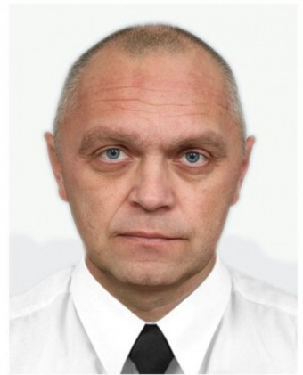

Experience:
Position | From / To | Vessel name | Vessel type | DWT | ME | BHP | Flag | Shipowner | Crewing
Electrician | 12.08.2008-19.01.2009 | сагитта | Dry Cargo | 6208 | 2204 | - | мальта |  | АТИС

Documents and further information:
МБЖС танкера пасажиры

