Панов Станислав Григорьевич
Position applied for: 2nd Officer  Date of birth: 29.07.1972 (age: 45)  Citizenship: Ukraine  Residence permit in Ukraine: No  Country of residence: Ukraine  City of residence: Odessa  Permanent address: Вильямса 81/3 кв100  Contact Tel. No: +38 (067) 487-05-13  E-Mail: panovi@te.net.ua  U.S. visa: No  E.U. visa: No  Ukrainian biometric international passport: Not specified  Date available from: 29.07.1972  English knowledge: Good  Minimum salary: 3100 $ per month | 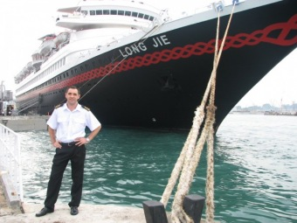

Experience:
Position | From / To | Vessel name | Vessel type | DWT | ME | BHP | Flag | Shipowner | Crewing
2nd Officer | 24.07.2008-21.03.2009 |  | Passenger Ship | 18500 | Sulzer | - | Панама |  | &mdash;
3rd Officer | 02.04.2008-20.07.2008 | Spiridin | Bulk Carrier | 3256 | Sulzer | - | Cambodg | Fahed | &mdash;

