Sachok Vladyslava Ivanovna
Position applied for: Assistant Chief Housekeeper  Date of birth: 04.04.1987 (age: 30)  Citizenship: Ukraine  Residence permit in Ukraine: No  Country of residence: Ukraine  City of residence: Syevyerodonetsk  Permanent address: st. Gagarina 104-154, city Severodoneck, r. Lugansk, Ukraine  Contact Tel. No: +38 (064) 525-25-35 / +38 (095) 106-73-74  E-Mail: lada_galaxy@mail.ru  U.S. visa: No  E.U. visa: No  Ukrainian biometric international passport: Not specified  Date available from: 22.04.2017  English knowledge: Excellent  Minimum salary: 2000 $ per month | 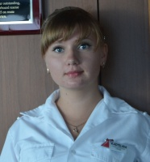

Experience:
Position | From / To | Vessel name | Vessel type | DWT | ME | BHP | Flag | Shipowner | Crewing
Assistant Chief Housekeeper | 03.05.2013-08.12.2014 | Valor | Cruise Ship | none | Italy | none | Panamanian | Italy | Miami
Cabin Steward | 11.08.2011-20.02.2013 | Fasination | Cruise Ship | none | Italy | none | Panamanian | Italy | Miami

Documents and further information:
C1D visa, seaman book, managment certificates

