Dovbnya Oleksandr
Position applied for: Motorman 2nd class  Date of birth: 15.05.1980 (age: 37)  Citizenship: Ukraine  Residence permit in Ukraine: No  Country of residence: Ukraine  City of residence: Nova Kakhovka  Permanent address: Street CSHorsa  Contact Tel. No: +38 (050) 868-72-48  E-Mail: telets2007@rambler.ru  U.S. visa: No  E.U. visa: No  Ukrainian biometric international passport: Not specified  Date available from: 17.09.2014  English knowledge: Good  Minimum salary: 1000 $ per month | 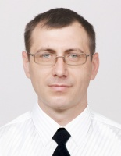

Experience:
Position | From / To | Vessel name | Vessel type | DWT | ME | BHP | Flag | Shipowner | Crewing
Motorman 2nd class | 17.02.2014-19.04.2014 | Aidar | Tug Boat | 1040 | 744 | 000 | Ukraine | DP "Ukrvodshlyakh" | DP "Ukrvodshlyakh"

Documents and further information:
I am able to do some welding. I work on the lathe.

