Myrza Ievgen
Position applied for: Chief Engineer  Date of birth: 28.07.1971 (age: 46)  Citizenship: Ukraine  Residence permit in Ukraine: Yes  Country of residence: Ukraine  City of residence: Odessa  Contact Tel. No: +38 (048) 725-65-65 / +38 (093) 852-57-70  E-Mail: eugenymirza@rambler.ru  U.S. visa: No  E.U. visa: No  Ukrainian biometric international passport: Not specified  Date available from: 30.10.2014  English knowledge: Good  Minimum salary: 12000 $ per month | 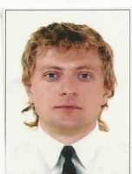

Experience:
Position | From / To | Vessel name | Vessel type | DWT | ME | BHP | Flag | Shipowner | Crewing
Chief Engineer | 05.07.2014-10.09.2014 | NSO Champion | PSV â Platform Supply/Support Vessel | 2500 | MaK | 4800 | Gibraltar | COG Offshore | CRS

