Torba Vadym
Position applied for: 3rd Officer  Date of birth: 09.11.1985 (age: 32)  Citizenship: Ukraine  Residence permit in Ukraine: Yes  Country of residence: Ukraine  City of residence: Mykolayiv  Permanent address: Elektronnaya 7/1  Contact Tel. No: +38 (051) 223-69-67 / +38 (063) 997-82-13  E-Mail: vadekt@rambler.ru  U.S. visa: No  E.U. visa: No  Ukrainian biometric international passport: Not specified  Date available from: 01.08.0201  English knowledge: Moderate  Minimum salary: per month | 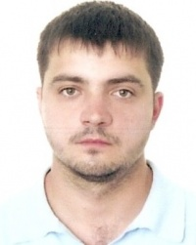

Documents and further information:
.

