Alex
Position applied for: Master  Additional position applied for: Chief Officer  Date of birth: 01.12.1984 (age: 32)  Citizenship: Ukraine  Residence permit in Ukraine: Yes  Country of residence: Ukraine  City of residence: Odessa  Contact Tel. No: +38 (096) 506-88-09  E-Mail: ukr-mail-alex@ukr.net  Skype: alex-alex-1984  U.S. visa: No  E.U. visa: No  Ukrainian biometric international passport: Not specified  Date available from: 28.06.2017  English knowledge: Good  Minimum salary: 1 $ per month | 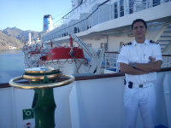

Experience:
Position | From / To | Vessel name | Vessel type | DWT | ME | BHP | Flag | Shipowner | Crewing
Chief Officer | 10.05.2013-28.08.2017 | Pax-RoroPax-Mrga Yacht-Refrigirator-DryCargo |  |  |  | - | St.Vincent |  | &mdash;

