Radcenko Oleksandr
Position applied for: 3rd Officer  Date of birth: 06.08.1992 (age: 25)  Citizenship: Ukraine  Residence permit in Ukraine: No  Country of residence: Ukraine  City of residence: &mdash;  Permanent address: str.Lavitskogo10 f39  Contact Tel. No: +38 (062) 937-46-14 / +38 (098) 367-90-09  E-Mail: fox.mettal@mail.ru  U.S. visa: No  E.U. visa: No  Ukrainian biometric international passport: Not specified  Date available from: 20.05.2014  English knowledge: Good  Minimum salary: 1500 $ per month | 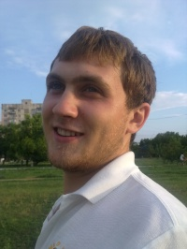

Experience:
Position | From / To | Vessel name | Vessel type | DWT | ME | BHP | Flag | Shipowner | Crewing
Deck Cadet | 06.05.2013-19.01.2014 | Portland | Bulk Carrier | 56880 |  | - | Marshall Islands | Azuline Shipping and trading S.A-Liberia | Bark

