Горячев Александр Николаевич
Position applied for: 3rd Engineer  Date of birth: 29.06.1982 (age: 35)  Citizenship: Ukraine  Residence permit in Ukraine: No  Country of residence: Ukraine  City of residence: Kherson  Permanent address: ул. 49-й Гвардейской дивизии,корп. 2,кв. 8  Contact Tel. No: +38 (063) 159-15-50  E-Mail: 11Aleksandrix11@mail.ru  U.S. visa: No  E.U. visa: No  Ukrainian biometric international passport: Not specified  Date available from: 01.08.2009  English knowledge: Good  Minimum salary: 3000 $ per month | 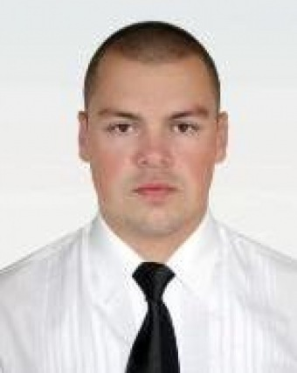

Experience:
Position | From / To | Vessel name | Vessel type | DWT | ME | BHP | Flag | Shipowner | Crewing
Motorman 1st class | 01.04.2009-02.06.2009 | Emerald Sea | Research vessel | 8455 | MAK | 9510 | Barbados | Jay Ray McDermott(CAN) | Seagull
Motorman 1st class | 12.12.2009-11.02.2009 | Emerald Sea | Research vessel | 8455 | MAK | 9510 | BAH | Jay Ray McDermott(CAN) | Seagull
Deck Cadet | 11.04.2008-25.07.2008 | Adeline Delmas | Container Ship | 33500 | Sulzer | 8200 | BAH | Delmas(FRA) | Bethel Traiding
Motorman 2nd class | 04.01.2007-21.07.2007 | Delphine Delmas | Container Ship | 33500 | Sulzer | 8200 | BAH | Delmas(FRA) | Bethel Traiding
Motorman 1st class | 30.04.2006-08.09.2006 | Etesco Millennium | Survey Vessel | 20048 | Gen. Motors | 13000 | BAH | Etesco Millennium N.V. (USA) | Arctur

Documents and further information:
Basic Safety; Syrvival Craft; Advanced Fire Fighting;Medical first aid; Dangerous Cargoes;Oil Tanker Familiarization;Oil Tanker Specialized; RO-RO Passenger;Breathing Apparatus.
Есть опыт в офшоре: 2 контракта на DSV/DP-2 и 1 контракт на Rig/DP-3 (на вышке).

