Denis Ravliuk
Position applied for: Ordinary Seaman  Date of birth: 15.10.1988 (age: 29)  Citizenship: Ukraine  Residence permit in Ukraine: Yes  Country of residence: Ukraine  City of residence: Kherson  Contact Tel. No: +38 (097) 935-28-93  E-Mail: d.ravlyuk@gmail.com  U.S. visa: No  E.U. visa: No  Ukrainian biometric international passport: Not specified  Date available from: 20.09.2014  English knowledge: Good  Minimum salary: 600 $ per month | 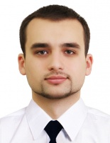

Experience:
Position | From / To | Vessel name | Vessel type | DWT | ME | BHP | Flag | Shipowner | Crewing
Deck Cadet | 07.12.2012-10.02.2013 | Okski-56 | Dry Cargo | 1312 | 8NVD-36-IU | 804.6 | Ukraine | Flora Delmas | &mdash;

